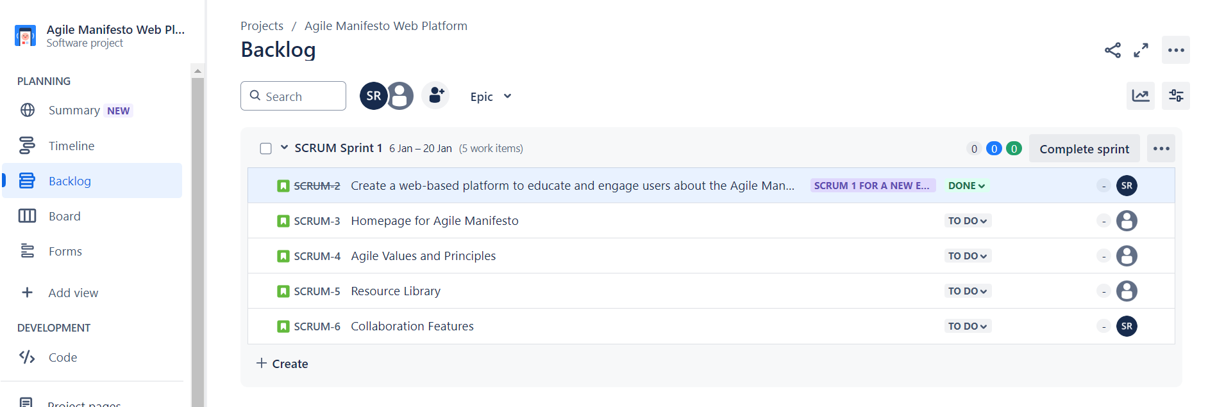

Dashboard Link - https://shakeelrifathcse.atlassian.net/jira/software/projects/SCRUM/boards/1/backlog